React

Class –State -> Render() -> return() , Function – return()

Npx create-my-app todoapp

cd todoapp

npm start

1. React Components are the lifelines of React which control mainly everything like Nav Bar , Search Bar, Footer , Forms etc.
2. Firstly, we need to declare the div with the id we have to control. Then head to the script tag and create a class. We will use Class based Components to create components. Then you need to extend the class to React. Component. This would work because you have included the script tag CDNs link int the head tag. Now we have to have a render() in this class(at least one function) and the use a return with parenthesis () and we need to write html-type code inside but this complete thing must be inside one particular element like <div></div> . While this div can have as many nested elements as it wants but you cannot have more divs or other elements in this function.
3. The return(), basically what we write in this parenthesis is the jsx file content. Also we are writing html type of code here but then we cannot have the class name for the elements because class is a reserved word in JS. So we have *className* doing the same here.
4. Now we need to install the Babel JS from the site because what we do here is not understandable to the browser and so for that we need Babel to make it browser supported.
5. Now as we create the jsx content, we need to render it to ReactDOM so that we have the output to the virtual dom using :

 <div id="app"></div>

    <script type="text/babel">

    class App extends React.Component

    {

        render() {

            return (

                <div className="app-content">

                    <h1>Hey, Yash</h1>

                    <p>{Math.random()*10}</p>

                </div>

            );

        }

    }

    ReactDOM.render(<App></App>,document.getElementById('app'));

    </script>

1. States of a Component – Its basically the dynamic data and the UI that is stored in the jsx file content.
2. For outputting dynamic data use { }.
3. When you go the console section and go to the components tab you can see the components and states being used by us. If you make any changes to the components then it will lead to an automatic change in the browser itself and renders it to the dom. So you can check that out as well.
4. When we include the <button use onClick={this[refers to this component].handleClick[function name..also there shouldn’t be any () at the end as we want to call it only on being clicked and not as soon as the page loads.]>Click Me</button>

          <button onClick={this.handleClick}>Click</button>

1. So like the onClick there are many events like onCopy[when user copies] or onMouseOver[Hovers] , onChange[used in form fields] you can fire functions. So theres a list to do so :

<https://reactjs.org/docs/events.html#supported-events>

1. When you use this in the render function it works but in case of other functions you need to bind it using : and can access the states of the component from the functions

       handleDoubleClick = (e) =>{

      console.log(this.state);

        }

1. Changing States : this.setState({name : “Yash”, age:30})
2. Forms :
   1. For updating the text fields as soon as we change anything :

handleChange = (e) =>{

           this.setState({

               name : e.target.value

           });

}

* 1. Preventing the page to be reloaded on submitting the form :

 <form onSubmit={this.handleSubmit}> //Firing this function everytime the form is submitted

handleSubmit = (e) => {

            e.preventDefault();

            console.log("Congrats, form submitted "+this.state.name);

        }

# React App

1. Now we will be working on apps as we need to build SPAs(Single Page Apps) which have many components and need to be handled with apps.

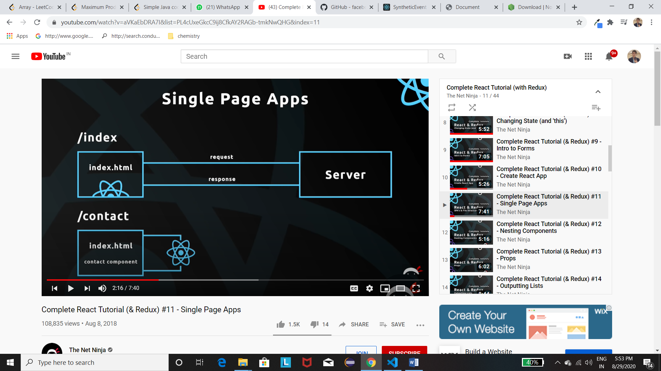

1. So we have the root id element in the index.html file. So we export he jsx file from App.js and then import in the index.js ,where we render it to root.
2. Then in the terminal type the other two in here: <https://github.com/facebook/create-react-app> This will open the page in the development server.
3. Nesting Components – So basically you can make a component and add it to the root component which then renders it to the dom.

So you need to create the component in the same format as we do and then just add 2 lines in the root component or any other components we create[we basically do that because we want to keep our code modular]

import Test from './Test'; //at the beginning

<Test />// where you want to put its contents

***WHATEVER NAME YOU MAKE START IT WITH A CAPITAL LETTER ELSE IT WONT WORK***.

1. Props(Short for properties) is used to pass data from the parent js to the child js(which is written in terms of tag). [This is used to make the child component reusable]

<Test name="Madhu" age="45"/>

        <br></br>

        <Test name="Yash" age="18"/> //this will call the same function twice with different values.

//How you use it in the other class

const {name,age} = this.props; //We always receive it as an object

        return(

            <div className="bio">

                <div>Name : {name} </div>

                <div>Age :{age} </div>

1. Outputting Lists – In this we do the above task only that we do it many numbers of times so it’s basically calling the same function again and again.
   1. So first we store the array of objects into the state of the parent class with a **unique id**.
   2. Then just pass the stored array into the tag with a variable name.
   3. Then in the child class receive it in an object.
   4. Then in the child class use that object in a map and then return them in the map itself in the same format as we returned earlier but with a **key** which will provide a unique id to each object.
   5. Then use the actual return to return map within curly braces.

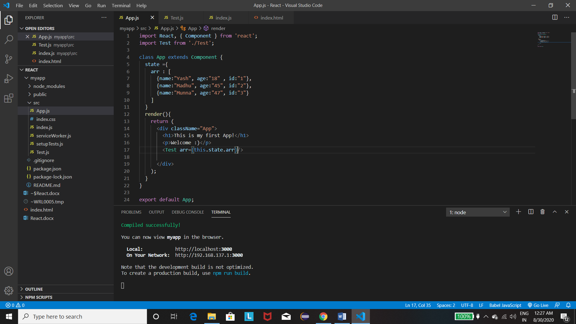

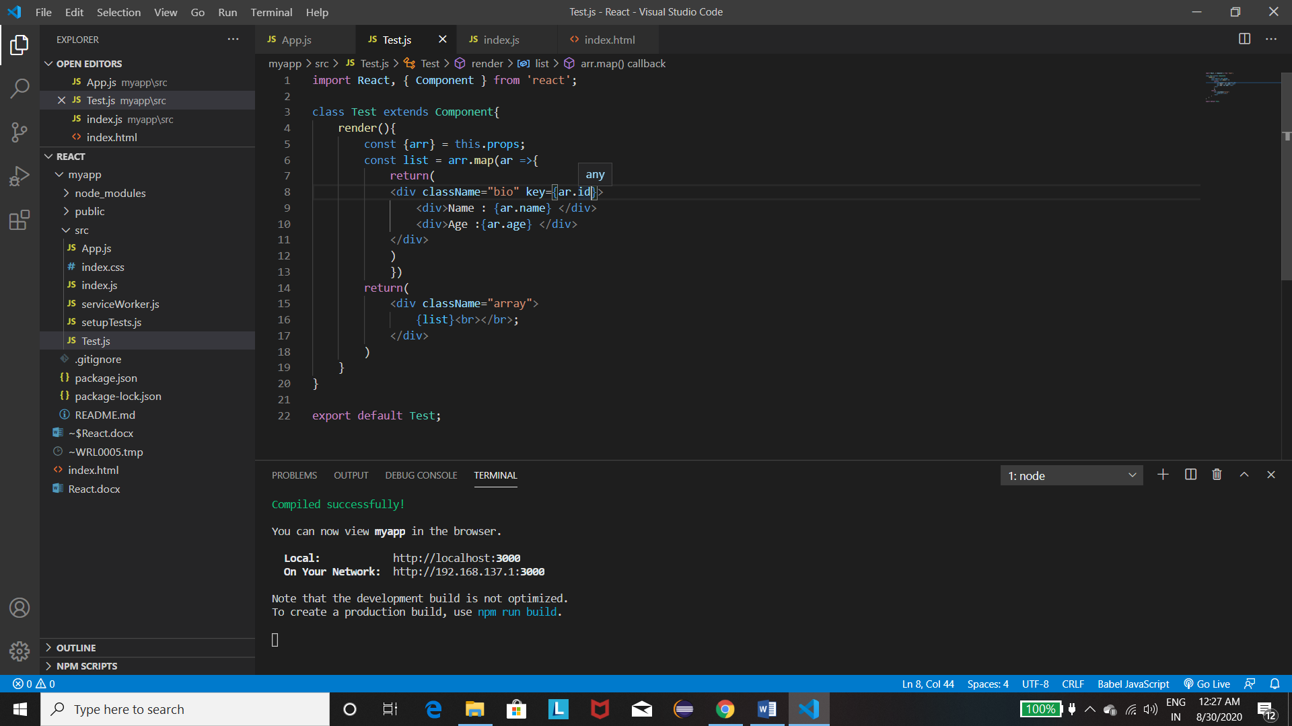

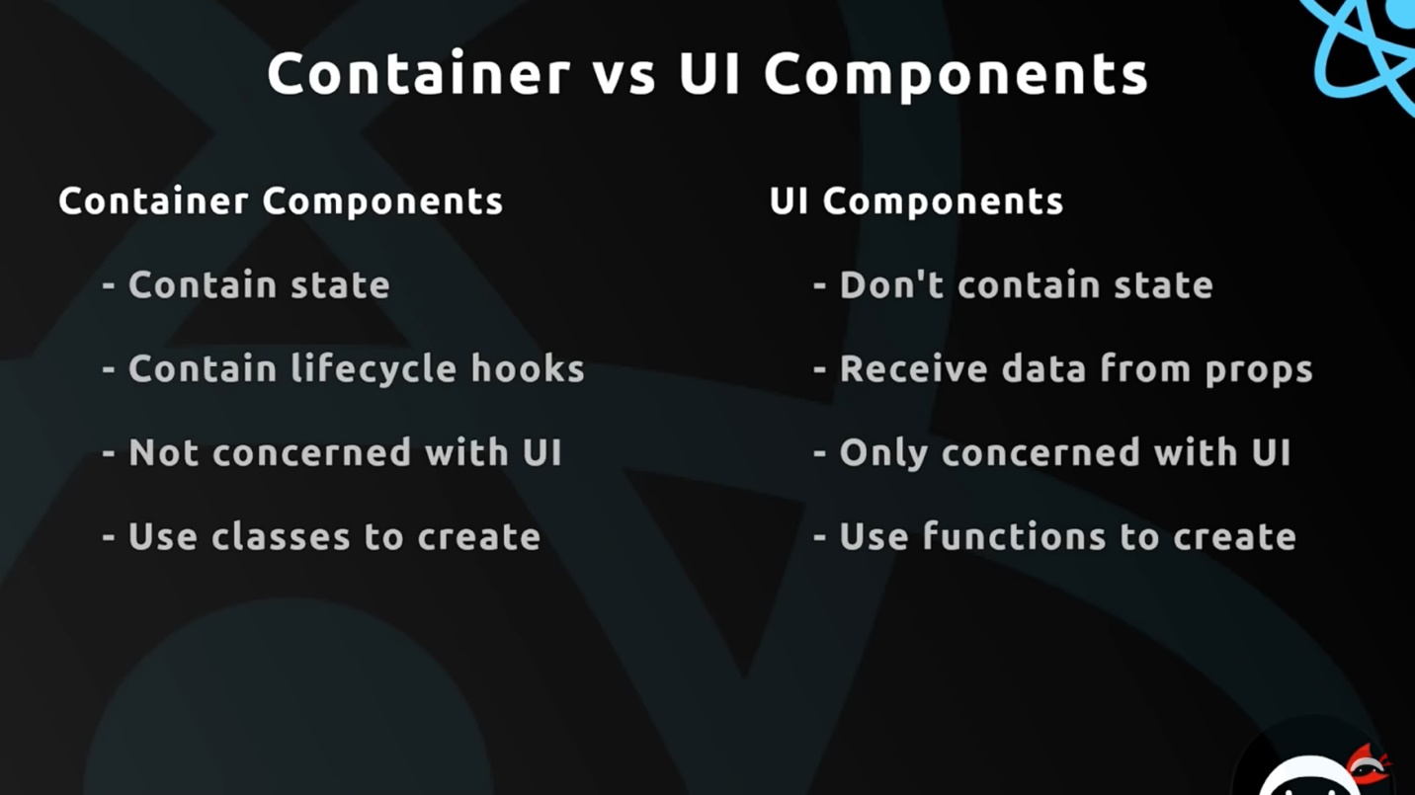

1. The pic above shows the UI components are made using functions so they need neither render nor state and hence no use of ‘this’.

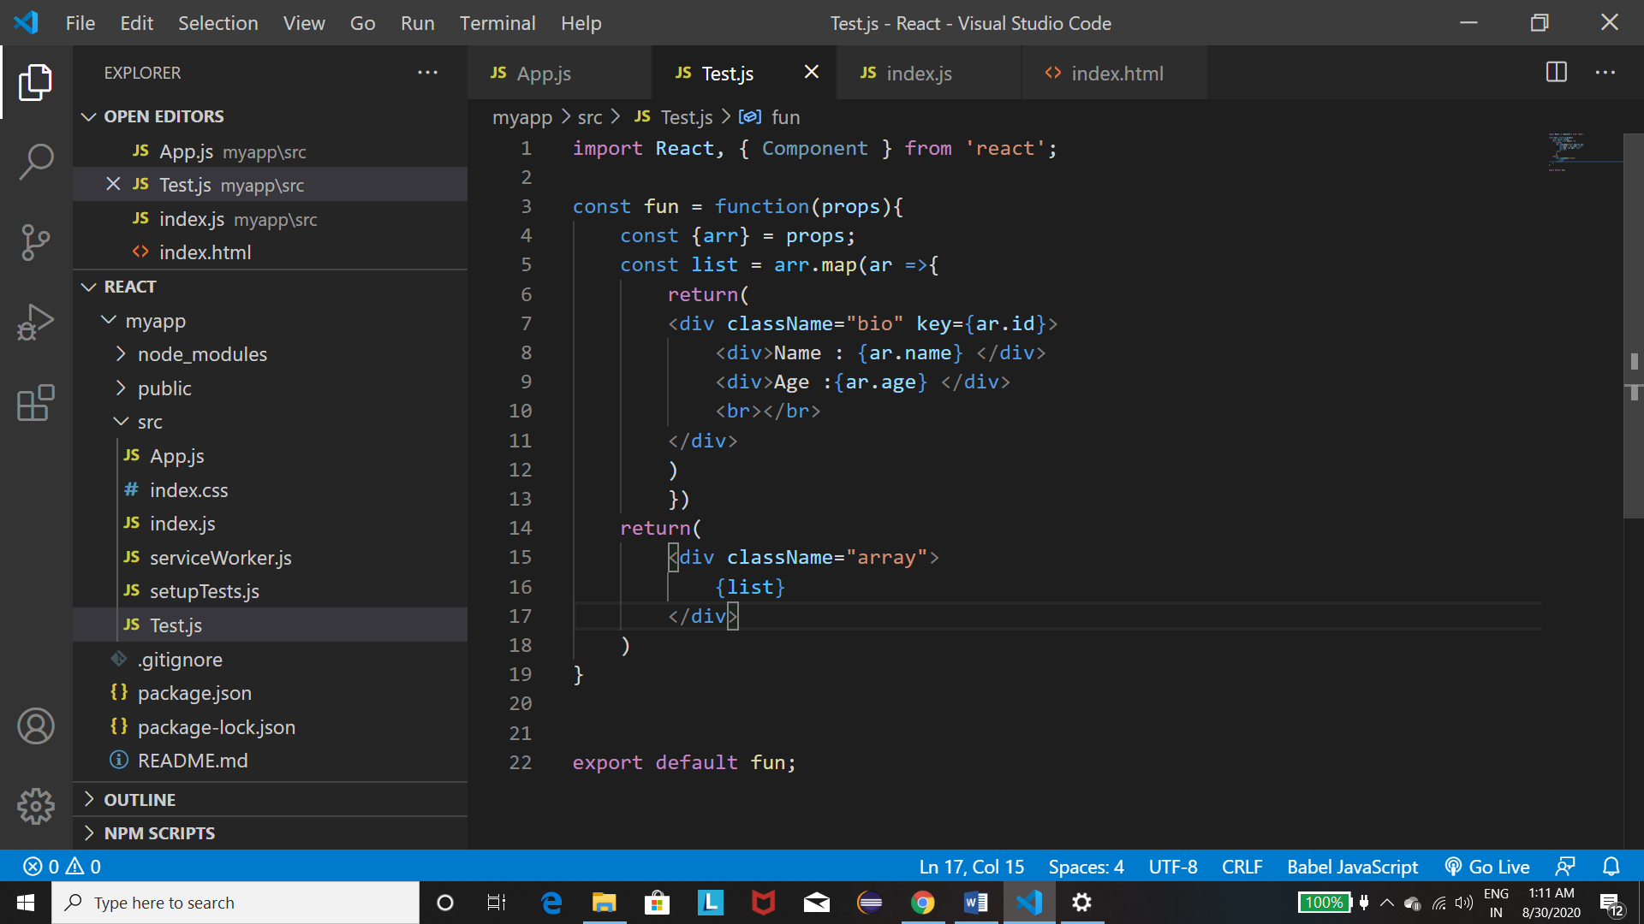

1. You can use the if statements in the map function to provide Conditional Output.
2. In the pic below we have only one thing new and that being how to use the id to set the state of the component , using the name within square brackets.

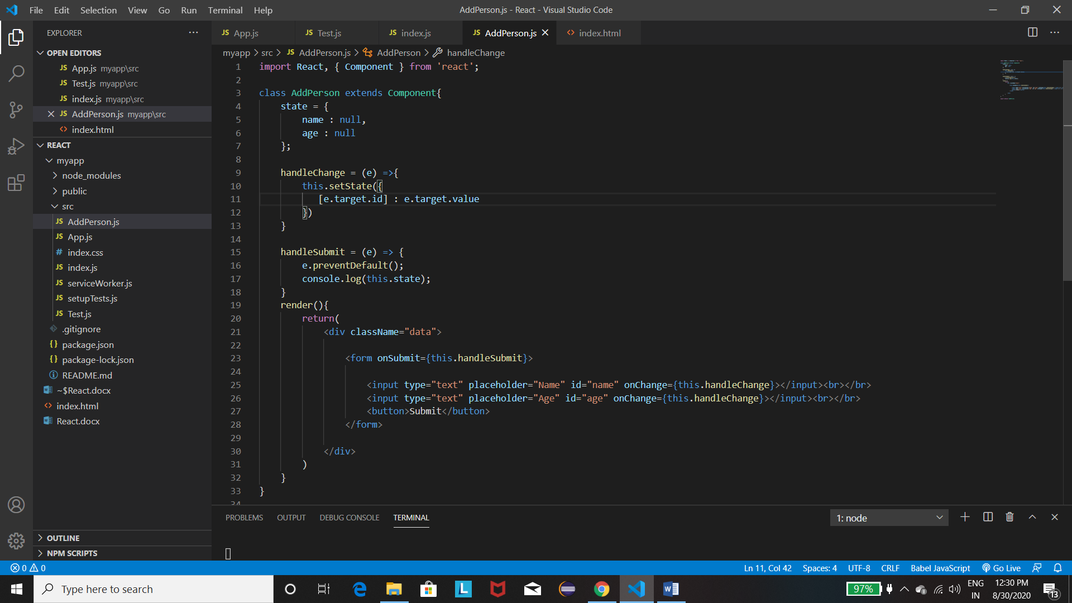

1. Now we want to pass info or data or states of the child to the parent. But we need to do this only using the props. SO we pass a function in the parent component as a prop to the child and in the child we add the info to the function which receives it as a parameter and then if we print the parameter in the parent we get what we sent from the child.

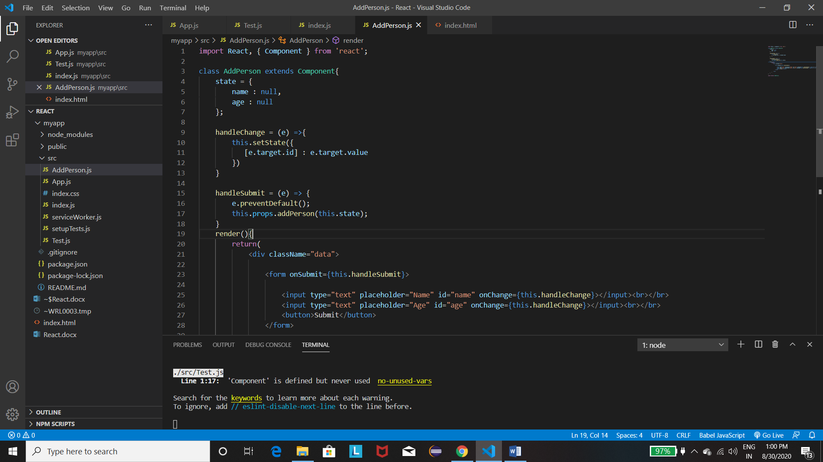

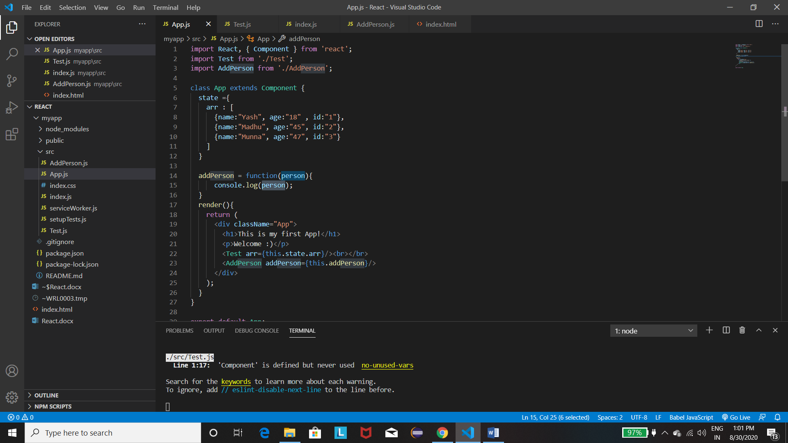

After this we need to update the state of the current component . But we cannot setState using the parameter directly as it is a bad practice. So we need to first make a copy of the current state using the spread operator(which basically does nothing but takes all the objects of the array one by one and pass it to the new array which we were making. Then we add our new object in the array. Finally using setState we just copy the array in the array of the state.

**Also that we need to use the Arrow Function else we wont be able to bind the function : addPerson = (person) => { … }**

1. Deleting an Object from the Parent state above : Its very similar to what we did above as passing functions as props, passing the id of the element to be deleted as a parameter. Now we will introduce the button while printing the object in the map function and use onClick. But in onClick we will have to use delete() with brackets to pass the parameter which we don’t want as it would invoke the function automatically and not when being clicked. So we have to use an anonymous function : { () => {delete(id)}}

Now in the function we need to delete the object whose id we get. We use **filter** in this case which is a non-destructive method which helps in removing an element under a condition. If we return true for that element then it will stay else it will be deleted.

**FUNCTIONING :**

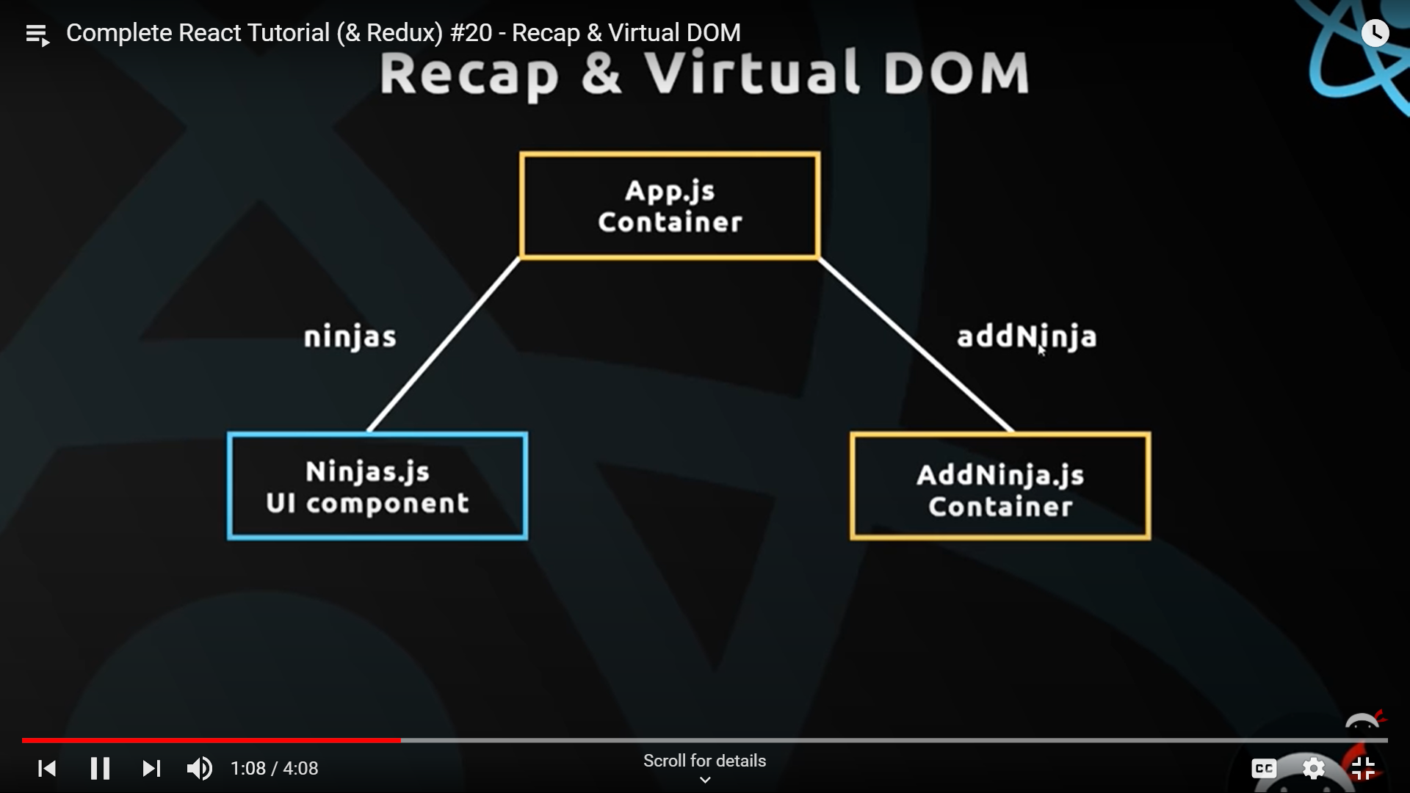

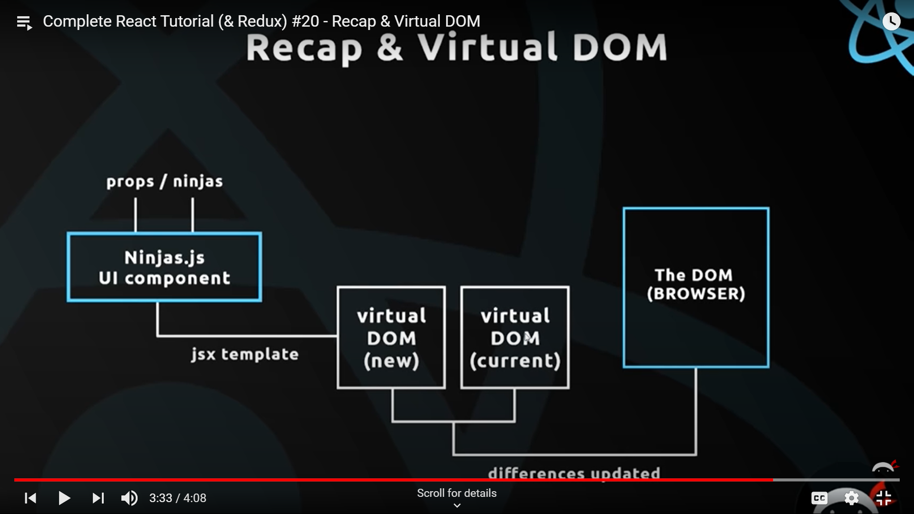

The New virtual DOM compares itself to the Current dom running in the browser and updates the differences and this cycle happens everytime theres a change in the props/data

1. For adding CSS make the css file for the component and import the file in that component : import ‘./AddPerson.css’

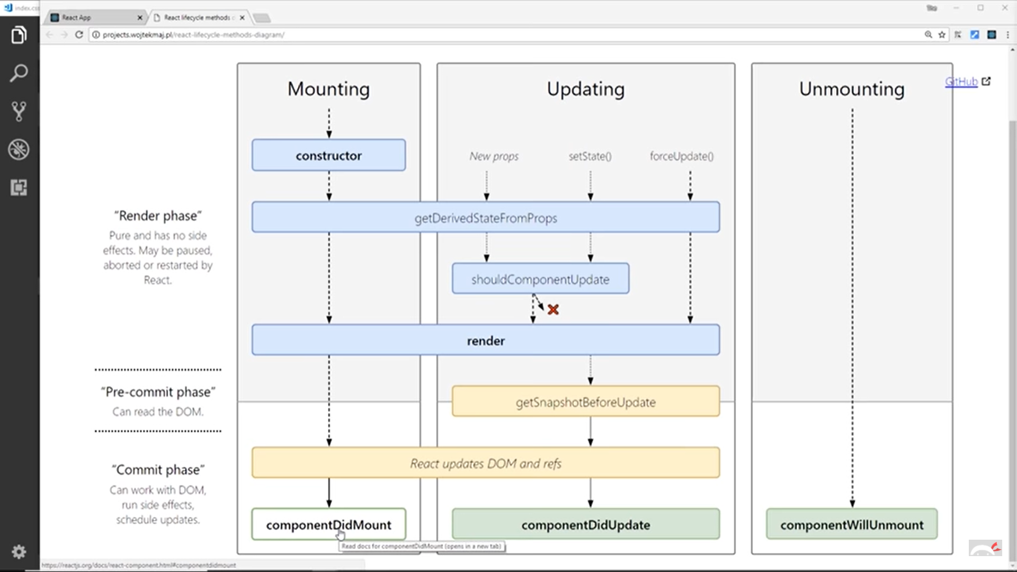

## To-Do App

1. Create using npx and npm.
2. Copy the css cdn link in the index.html file in the public folder.
3. Firstly create some states to output.
4. Make a component to display them. The name of the div for outputting them will be collection as it would help in css styling.
5. Everything possible needs to be done in the main App.js file.
6. See everything mainly from the program
7. Lastly we need to remove everything from the input tab after we submit so set the state to null and then set the value={this.state.content} of the input.

CSS for React :

1. Classname=”blue-text” – blue color
2. Classname=”center” – center alignment
3. Cn=”collection” – border
4. Cn=”collection-item” – no borders but proper placements
5. Cn=”container” – provides a proper border(used with App class)
6. Nav-wrapper – used with cn in nav tag.
7. Cn=”red” – colour background

## **React Router(Multiple Pages) and Poke’Times**

1. When we want to access the home page we send a request to the server but when we want to go to another page , we don’t go to the server again but instead we use the React Router which intercepts the connection and injects that page in the App.js file : 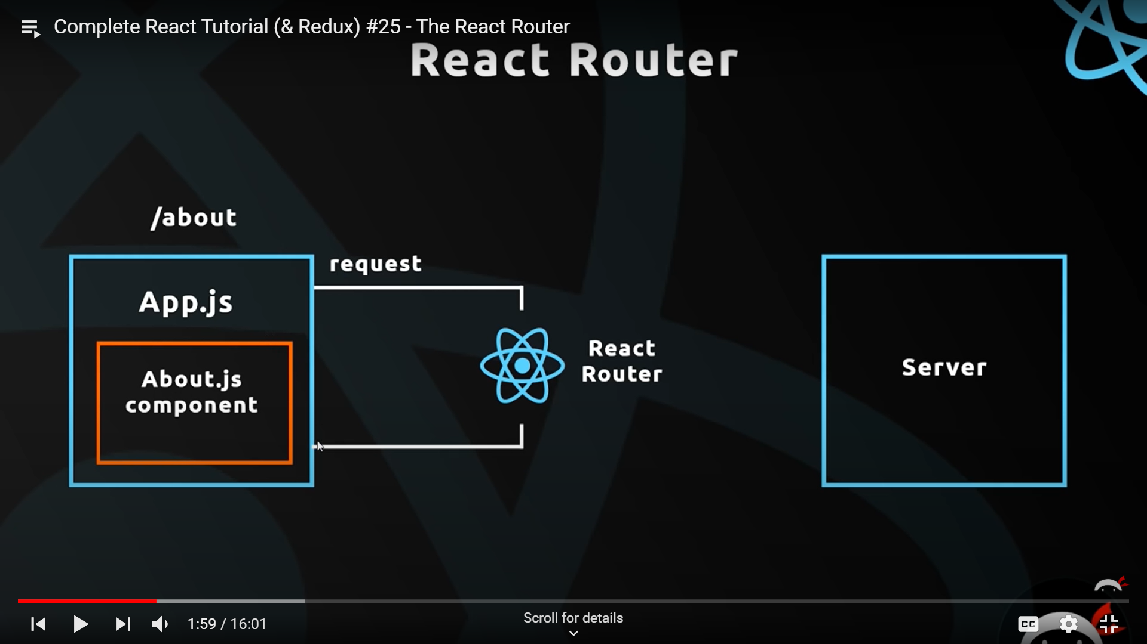
2. Cd poketimes

Npm install react-router-dom // Used for installing the React Router

1. For using the above installed thing , import {BrowserRouter , Route } from ‘react-router-dom’. Enclose the div tag(after return ()) with <BrowserRouter></BrowserRouter> tags.

Finally use the <Route path=’/Home’ component={Home} /> to make this page work and similarly use the other pages. Also we import these components above.

1. Now using the above makes the page reload and so we need to work with Link and NavLink in the NavBar to use the router feature. Import the two above using the same as Route and then replace the anchor tag with Link and href with to=”/Home”.

Also difference between Link and navLink is that an extra class is provided in the NavLink tag.

1. Now in Route, theres a special property that the props in this have a predefined object. We can use that for a Programmatic redirect(a redirect after some time without clicking any button). So for now we have the Home,contact and the about In the Route now.

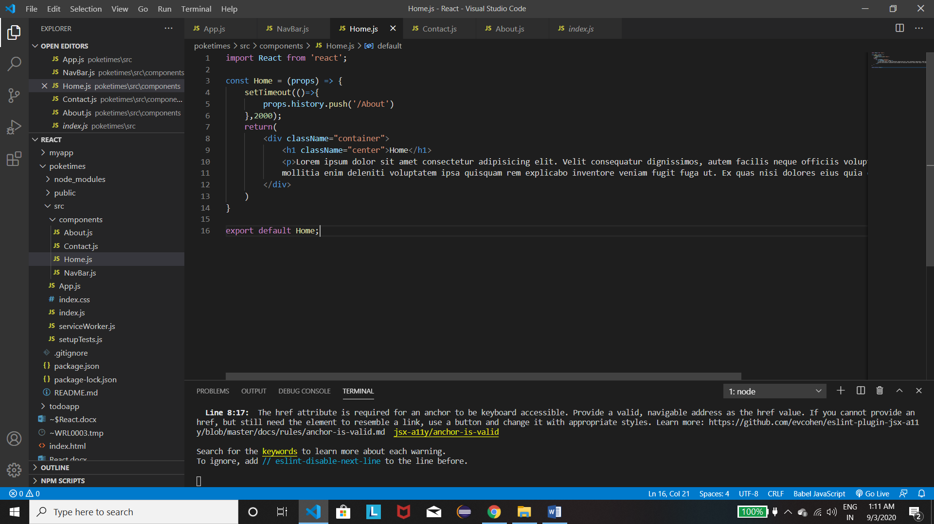

1. Now providing the same property to Navbar wont work as the navbar is not a Route. So what we need to do here is provide a Higher Component to the NavBar. Now a higher component Is basically a function which surrounds the navbar and provides additional powers to it. In this case it’s the withRouter thing that acts as the Higher Component.

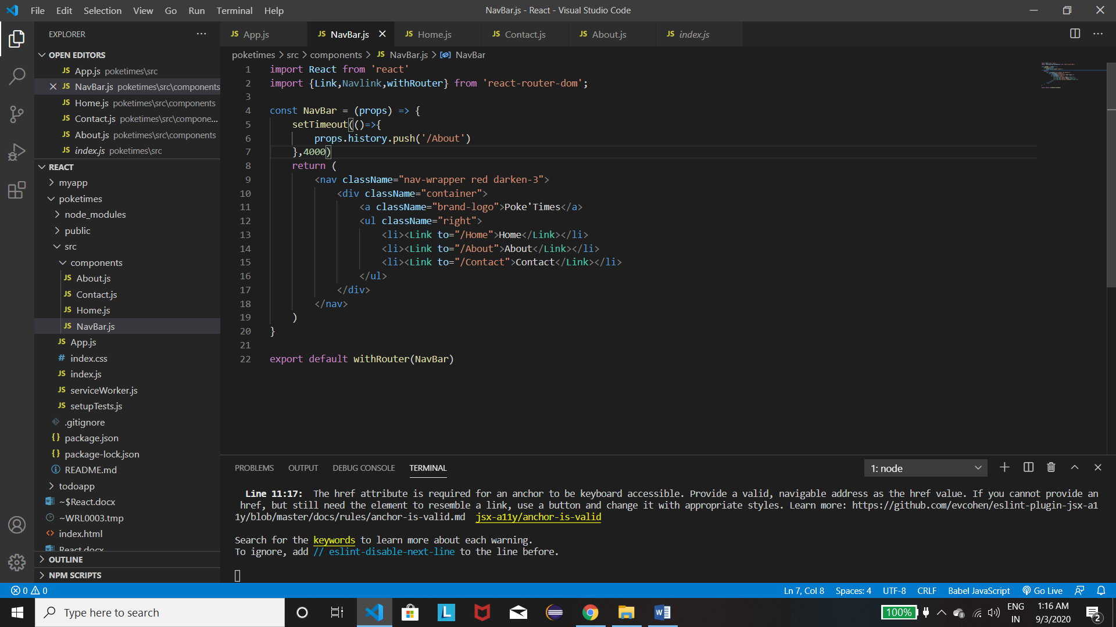

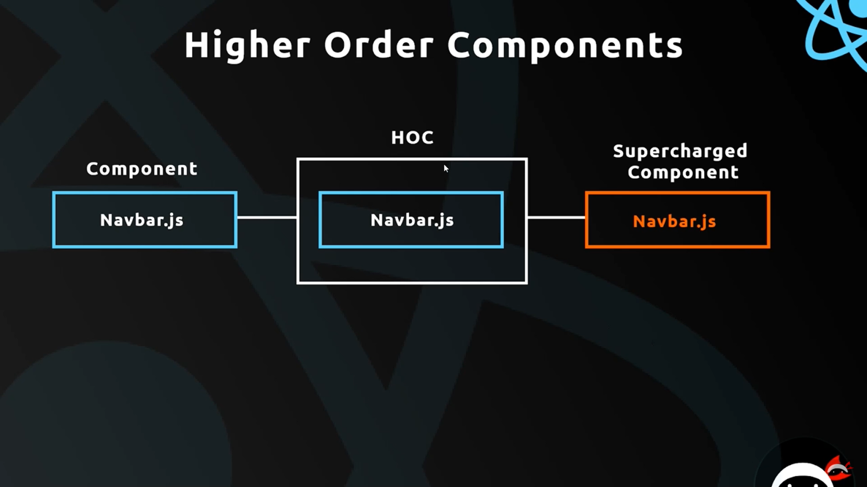

1. Making a custom Higher Order component – What we initially need to do is receive the component into WrappedComponent and then return the Component again with some modifications like adding a new class , while other stuffs remains the same :

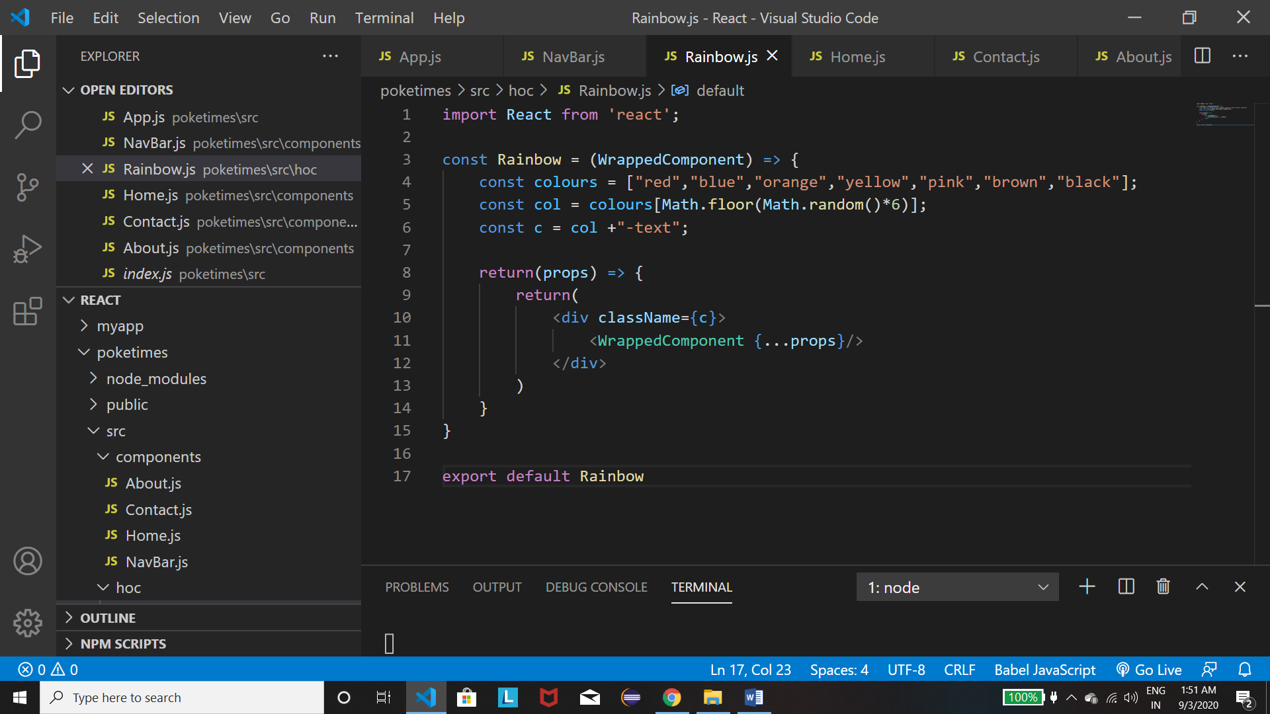

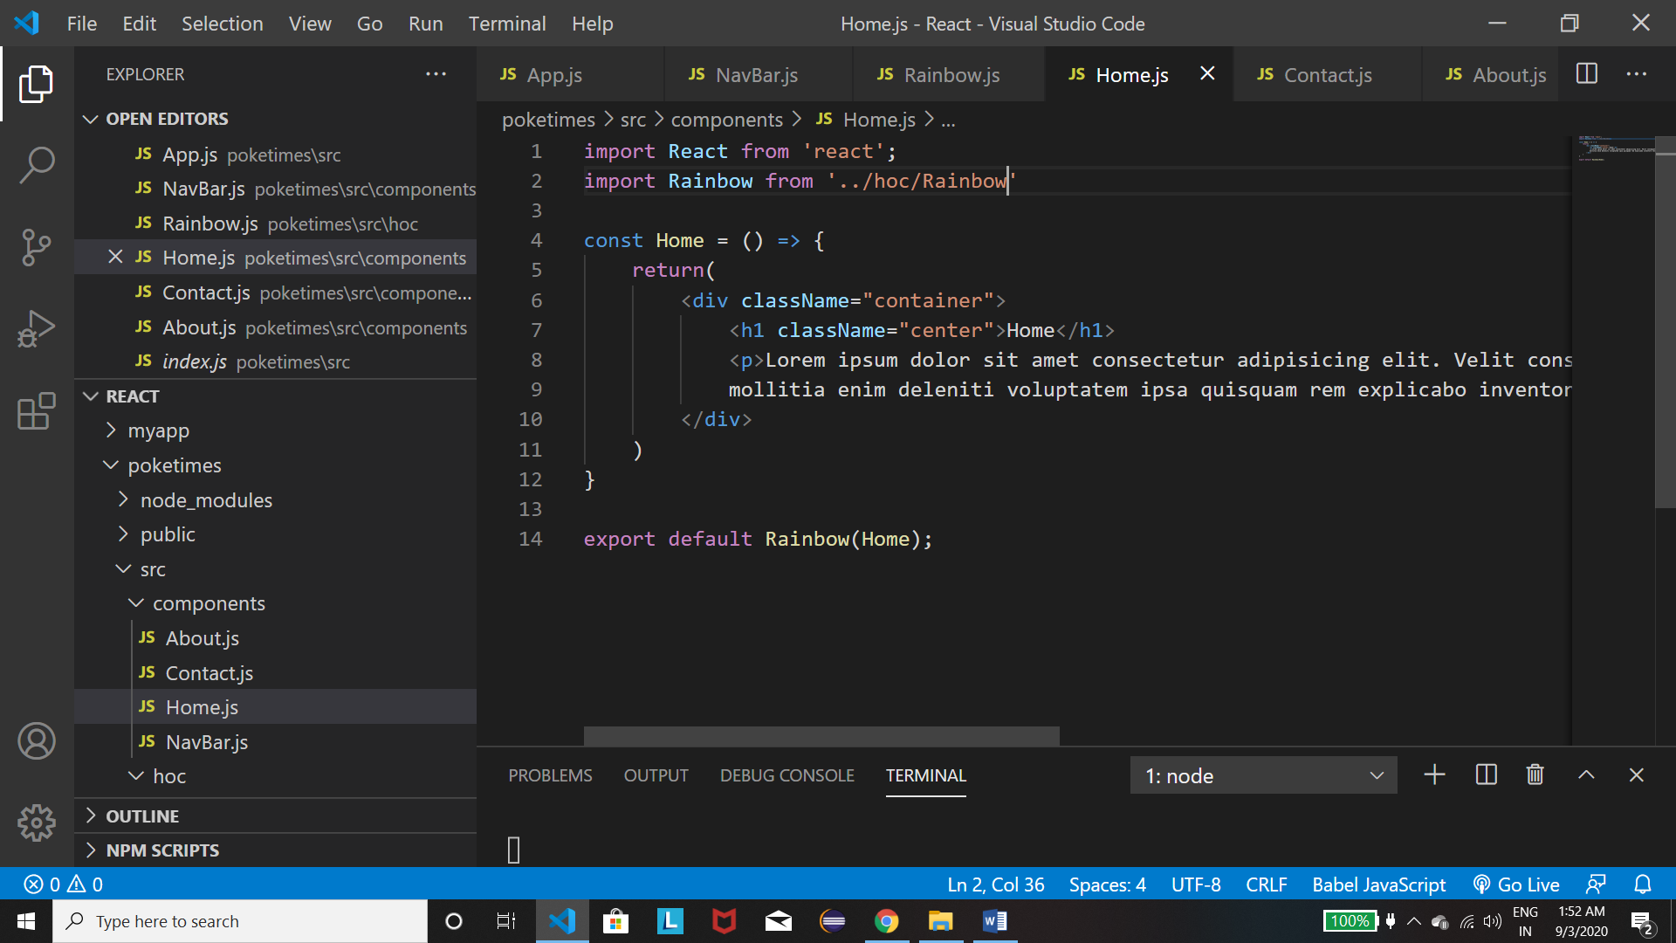

1. Now we receive data from third party APIs using Axios – First install using :

Cd poketimes

Npm Install axios

Now the best time to receive data is in the lifecycle hook when the mounting is done. So first we need to convert functional component into the class based as lifecycle hook works on classes only.

So then import axios from axios and then make the function componentDidMount(){ //Fetch the data here using get. Now we this fetching takes time and so we have to use the .then() method to continue only when this data retrieval ends. After we setstate we will cycle throught the state and make the data output to the user.

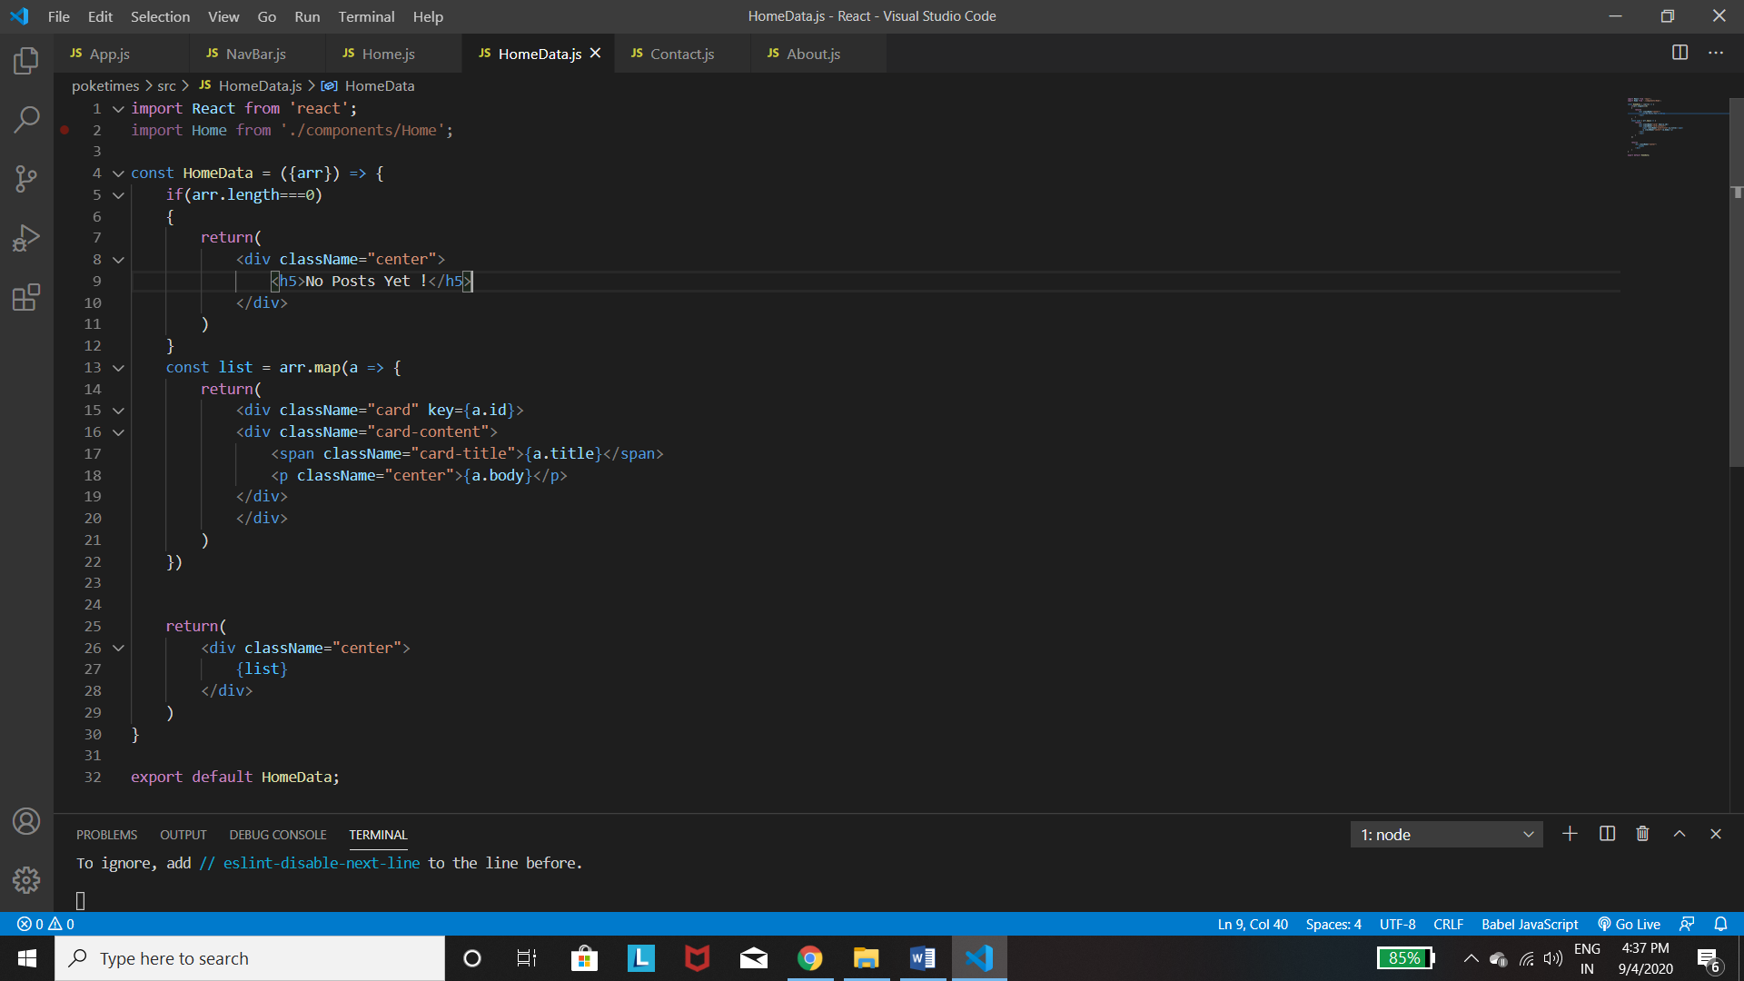

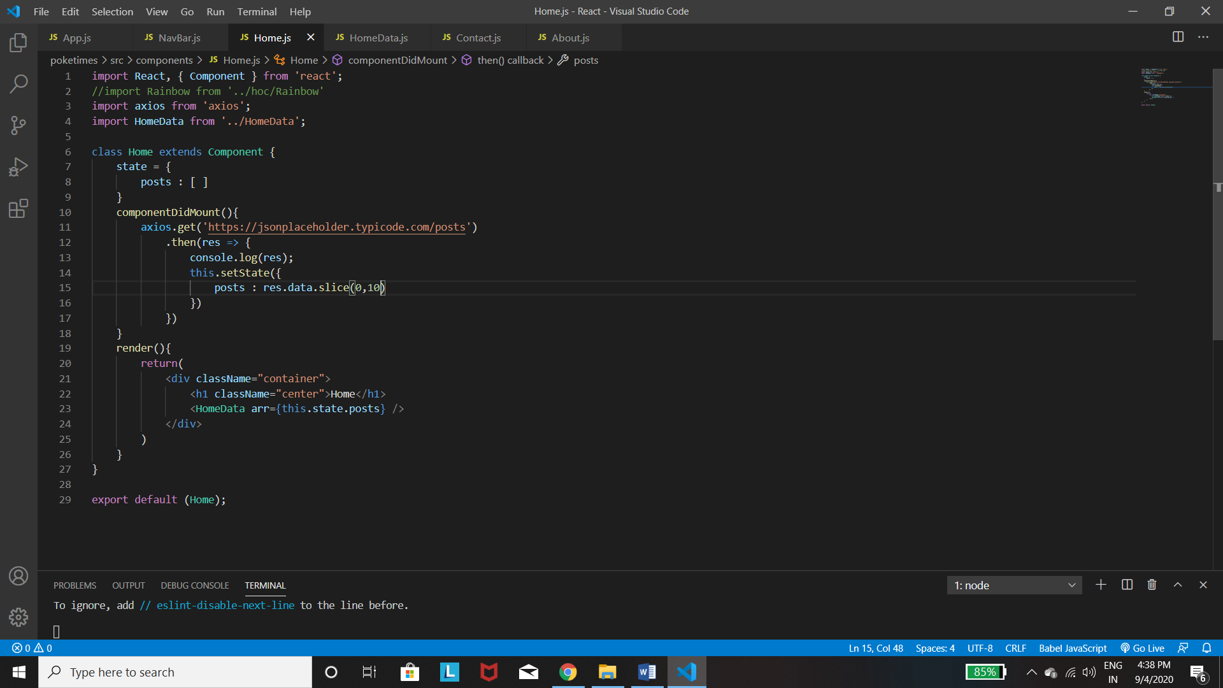

1. 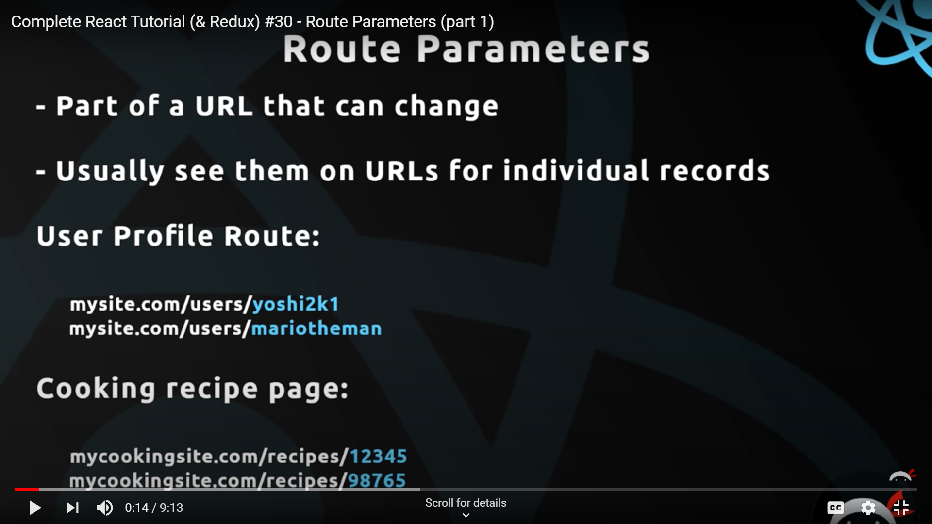

For the Route parameters we mean is the template of the page remains the same , but everytime we have a different data passed to it and the URL of the page is the page url in which we are /{the id of the page] as shown above.

*The Link ‘to’ is just the same as href for a tag and so when we click it goes to that page and the class receives the id which again will be received by class based components.*

Now we need to make a variable post route so that if we click on the post then it gets its id and returns its data. So we use the variable Id route using :

<Route path='/:post_id' component={Post} />

Now we use props to get the id. As we are using class based components so we get the props by default and in these props we have the id of the page in thi.props.match.params[as we have the post_id in this]

Now for using these concepts to link the data in the json file, we need to make the title a Link tag with the to part as the id and the id will fetch the data from the json file using the mount function and as soon as we get it we update the state and using the state we output it to the user. Finally we make Post.js as we are calling this component via the Route tag.

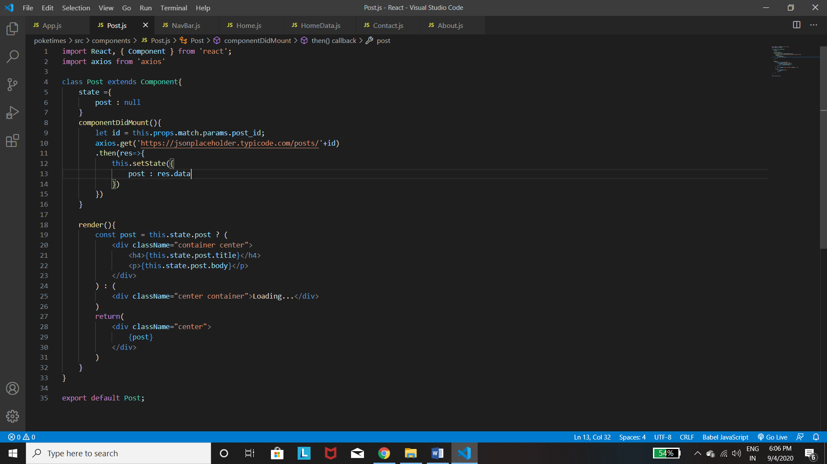

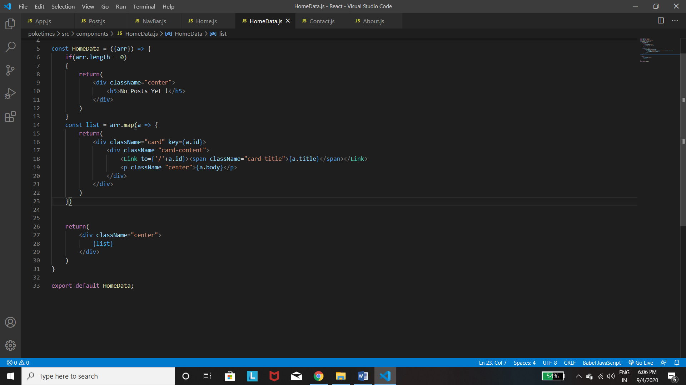

*Also here we see that when we open home,contact or about page it loads up the post id as well and so we need to tell the program to use only one of the Routes at a time and not all. So we use the* ***Switch*** *tag to surround the Routes which allows only one of the Routes to function , searching from top to bottom. Note – Import that first from react-rouer-dom*

*Also when inserting images use position:absolute(in case you don’t want to provide space to them) and then use* ***padding-left*** *for providing them space and could use the overflow:hidden for hiding outside the div.*

REDUX

1. Central data store for all our app data. Any component can access data from it and thus makes the State management easy.

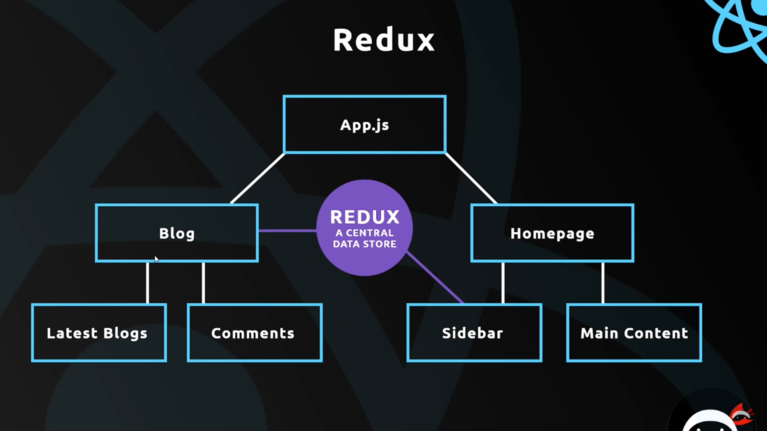

The above image indicates that when two components need the same data it uses Redux as the central data store.

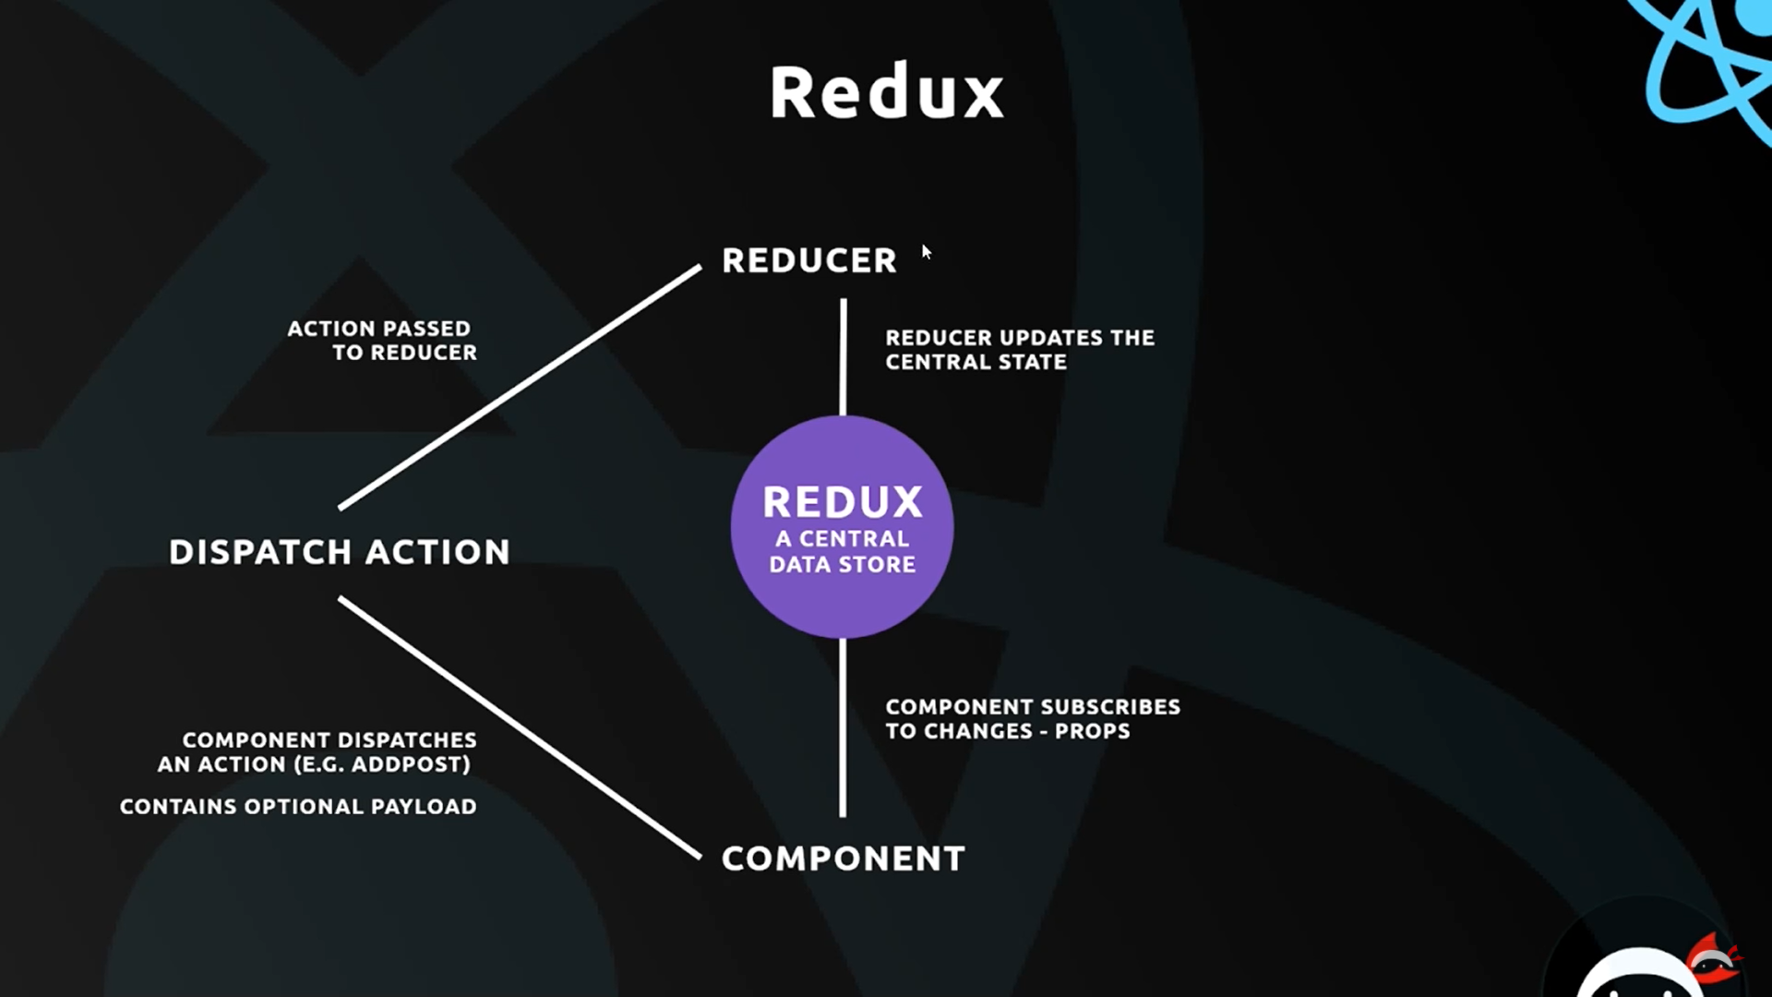

The Additional file may be the new data that we want to add to it.

1. By the above diagram we can say that only the Reducer has the access to the Store to change the data so we bacially have the Reducer as the parameter whenever we create the redux store to know which reducer controls the data changes.
2. So when we are using Redux in CodePen , it means we are creating a Store using the Redux Library.

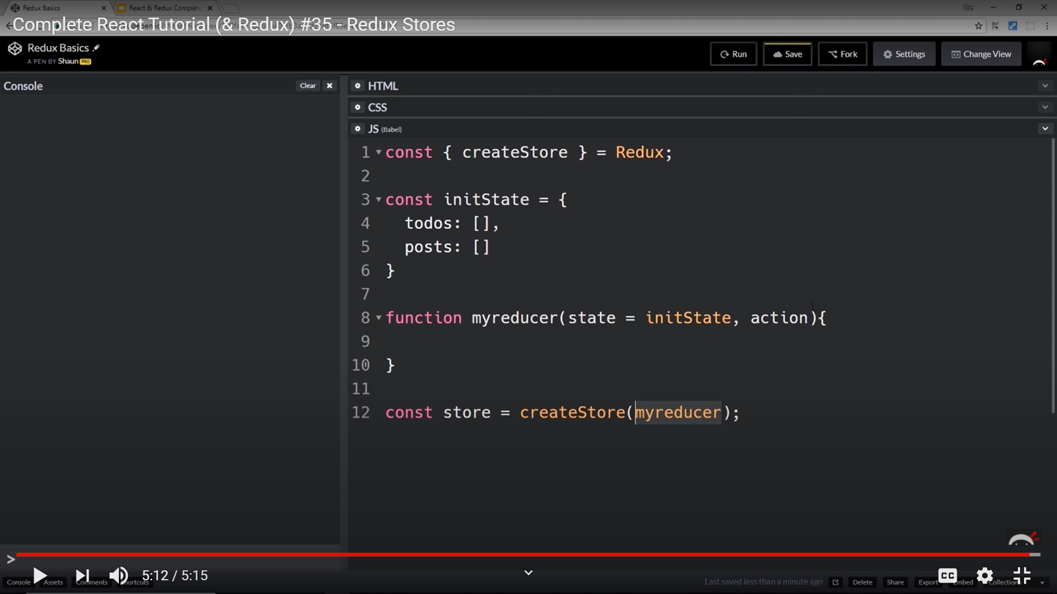

So above we create the Store using the Redux library and then we create an initial state which we will have to pass in the reducer function(as the reducer takes the state of the store as a parameter but initially it doesn’t have the access to it and so we need to pass a dummy state to it which we create now.) Then pass this state as a parameter along with an action in the reducer function. Then we create the store using the store above and passing a reducer function as a parameter to it.

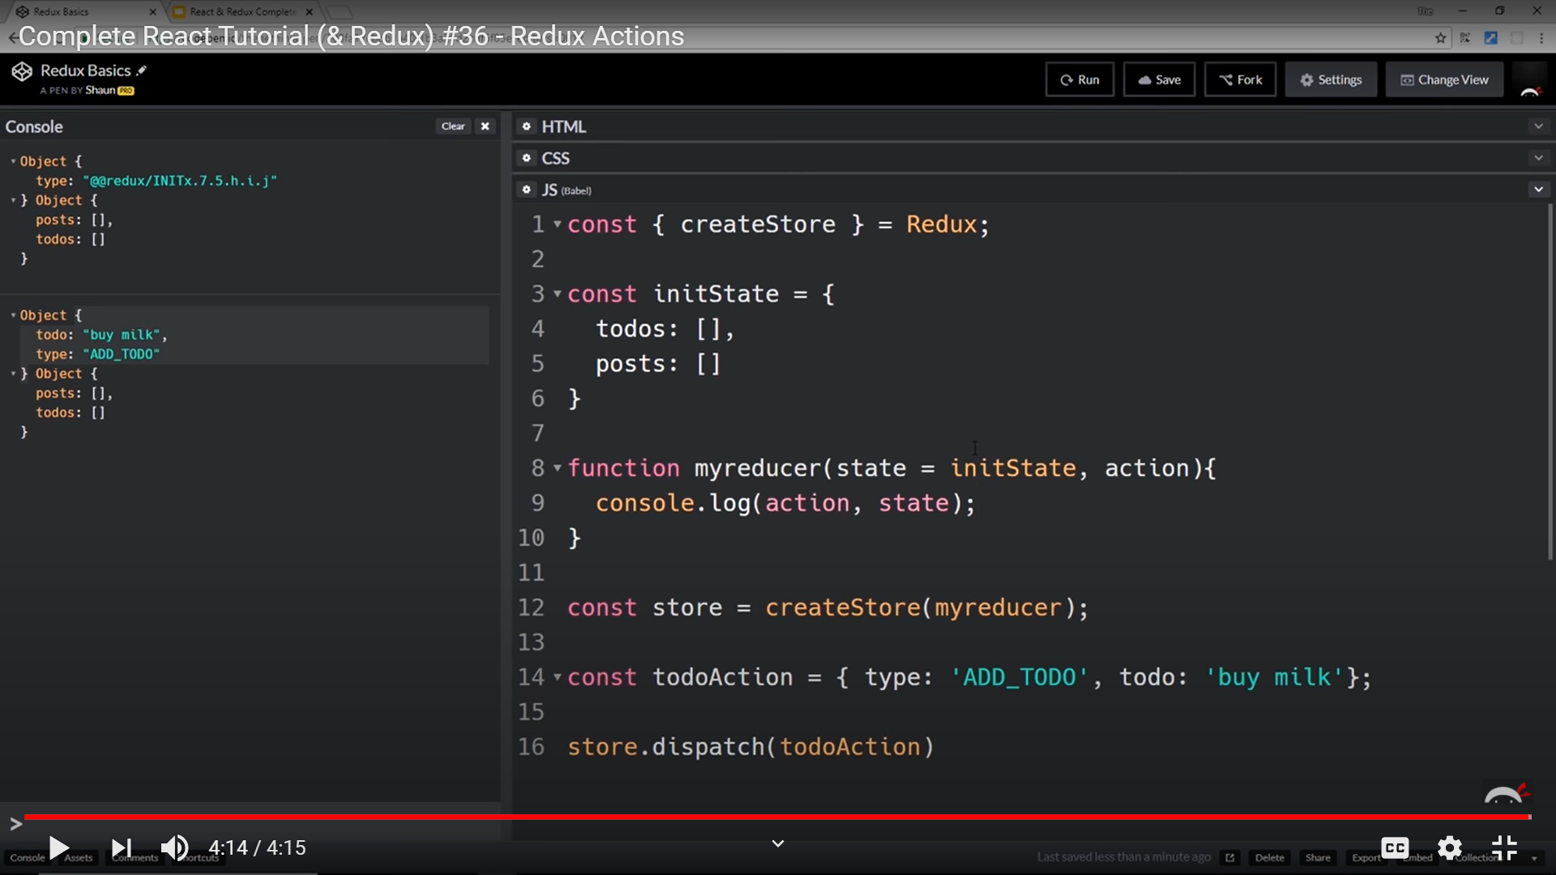

1. Now we create an Action which we have to Dispatch to the Reducer. Now the Action is an object with type and content (as todo above) and then after creating we need to dispatch it to the store. So then the Reducer gets automatically called after dispatching and this can be seen when we get 2 output at the console that the second call was using Dispatch.
2. 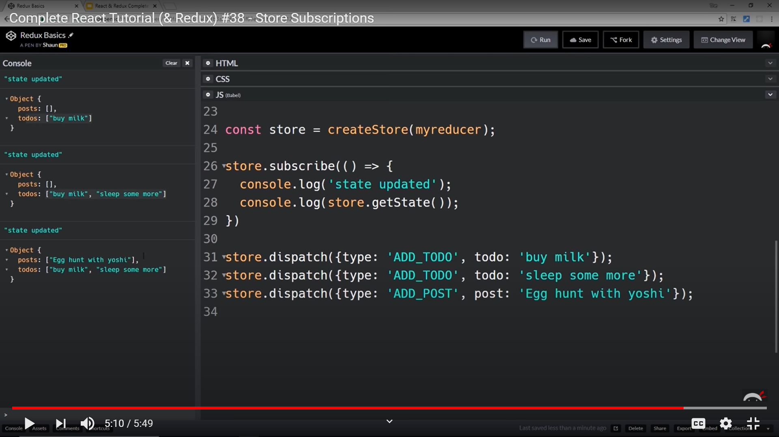

Now all we need to do is subscribe to the component. Now here we don’t have any component so we just log it to the console but in components we attach the store’s state as props to the component.

Also we write just the todos : [] in the reducer part becoz only that gets updated. But actually we need to update all the other states as well , so we use …state, todos : [] , in the reducer and then update the todos.

# Redux With React :

1. Firstly install redux react-redux. The first is the library and then the second is the connection between the two.
2. Now import the {createStore} from Redux to build the store and finally import {Provider} from ‘react-redux’ in the index.js file where we bind the App to the DOM. Then we surround the App tag with the Provider tag with store={store} which you create above. Then we create a reducer folder for better management.

Then in the folder we make the rootReducer function in which we make our reducer without importing stuffs.

1. **Connecting Components to the Store:** 
   1. So firstly we need to import {connect} from react-redux[remember this is the glue line].
   2. Then we wrap the component with the connect()(Home) as this connect is a function which returns a higher order component and then wraps I around Home component. The connect function also takes a function as a parameter.
   3. Also don’t forget to add data to the posts state of the reducer which we will grab. Now we know that the components receive the data from the redux store via props.
   4. Then we create the const mapStatetoProps(state) function which receives the state of the store as parameter and then we return an object in which we add the data that we want to add to the props. So we add the state.posts to a post array in the prop.
   5. We remove the state from the component as we don’t need it as the central idea of Redux is to store data.
   6. *Also make the reducer function { return state } ,* as if it doesn’t return the state then it wouldn’t be used by the components.
   7. Finally using the props as the data store for the component.
2. Now when we apply this to the posts part of the poketimes app, we see that we have to get the data from the id of the app. So we connect the Post component to the redux as explained above. Then in the maptoState part we give 2 parameters. Firstly the state , then the **ownProps ,**which will contain the default props for the component as it was called via the route when we hit the link of the id. Now using the default props we can get the id and then save it in a variable and then we can use the id to find the post which has the same id.

**Note : That when we used post.id===id we are comparing a string to number. So we have to use post.id===parseInt(id) to have the proper check.**

1. **Deleting Posts(Via Dispatch) :**
   1. So we need to make the const mapDispatchToProps which receive dispatch as a parameter.
   2. Then we need to return the function that we need to send it to the props which basically is the action that we need to take.
   3. The deletePost(function) receives an id as parameter and then write { dispatch({type:’’, id/optional payload:’’}) This will dispatch the action to the reducer function which could be seen by logging the action to the console.
   4. Now we use the type we receive using if and then making a newPost(using filter) and then return using the …state operator for overriding the entire state.
   5. Finally use the this.props.history.push(‘/Home’) to redirect the user to the home page as soon as we delete the post.
2. Action Creators – These are basically files that help us to make our actions reusable(which means we could have written dispatch({type:’’,id:’’}), but we prefer dispatch(deletePost(id)),and this deletePost =(id)=> function needs to be imported ) and can be used in from different components.
   1. We make a new file in which we make the **const deletePost** function in a very similar way and then export that to the Post and receive it.\

**[NOTE :** *LifeCycle Hooks :* **React** class components can have **hooks** for several **lifecycle** events. **Hooks** allow function components to access them too, in a different way. During the lifetime of a component, there's a series of events that gets called, and to each event you can **hook** and provide custom functionality.]